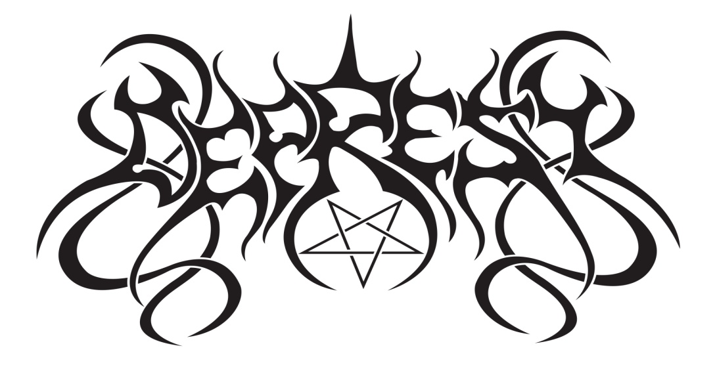

1. **Psycold**
2. **Self Ignition**
3. **Palliative Theories**
4. **Escapism**
5. **Rehab Triplet**
6. **Tribute To Melancholy Day**
7. **Reality Architects**
8. **The Antichrist´s Philosophy**
9. **Visions**
10. **Thanatocenosis**

**Bonus: Try not to breathe, Crepuscular Conquest**