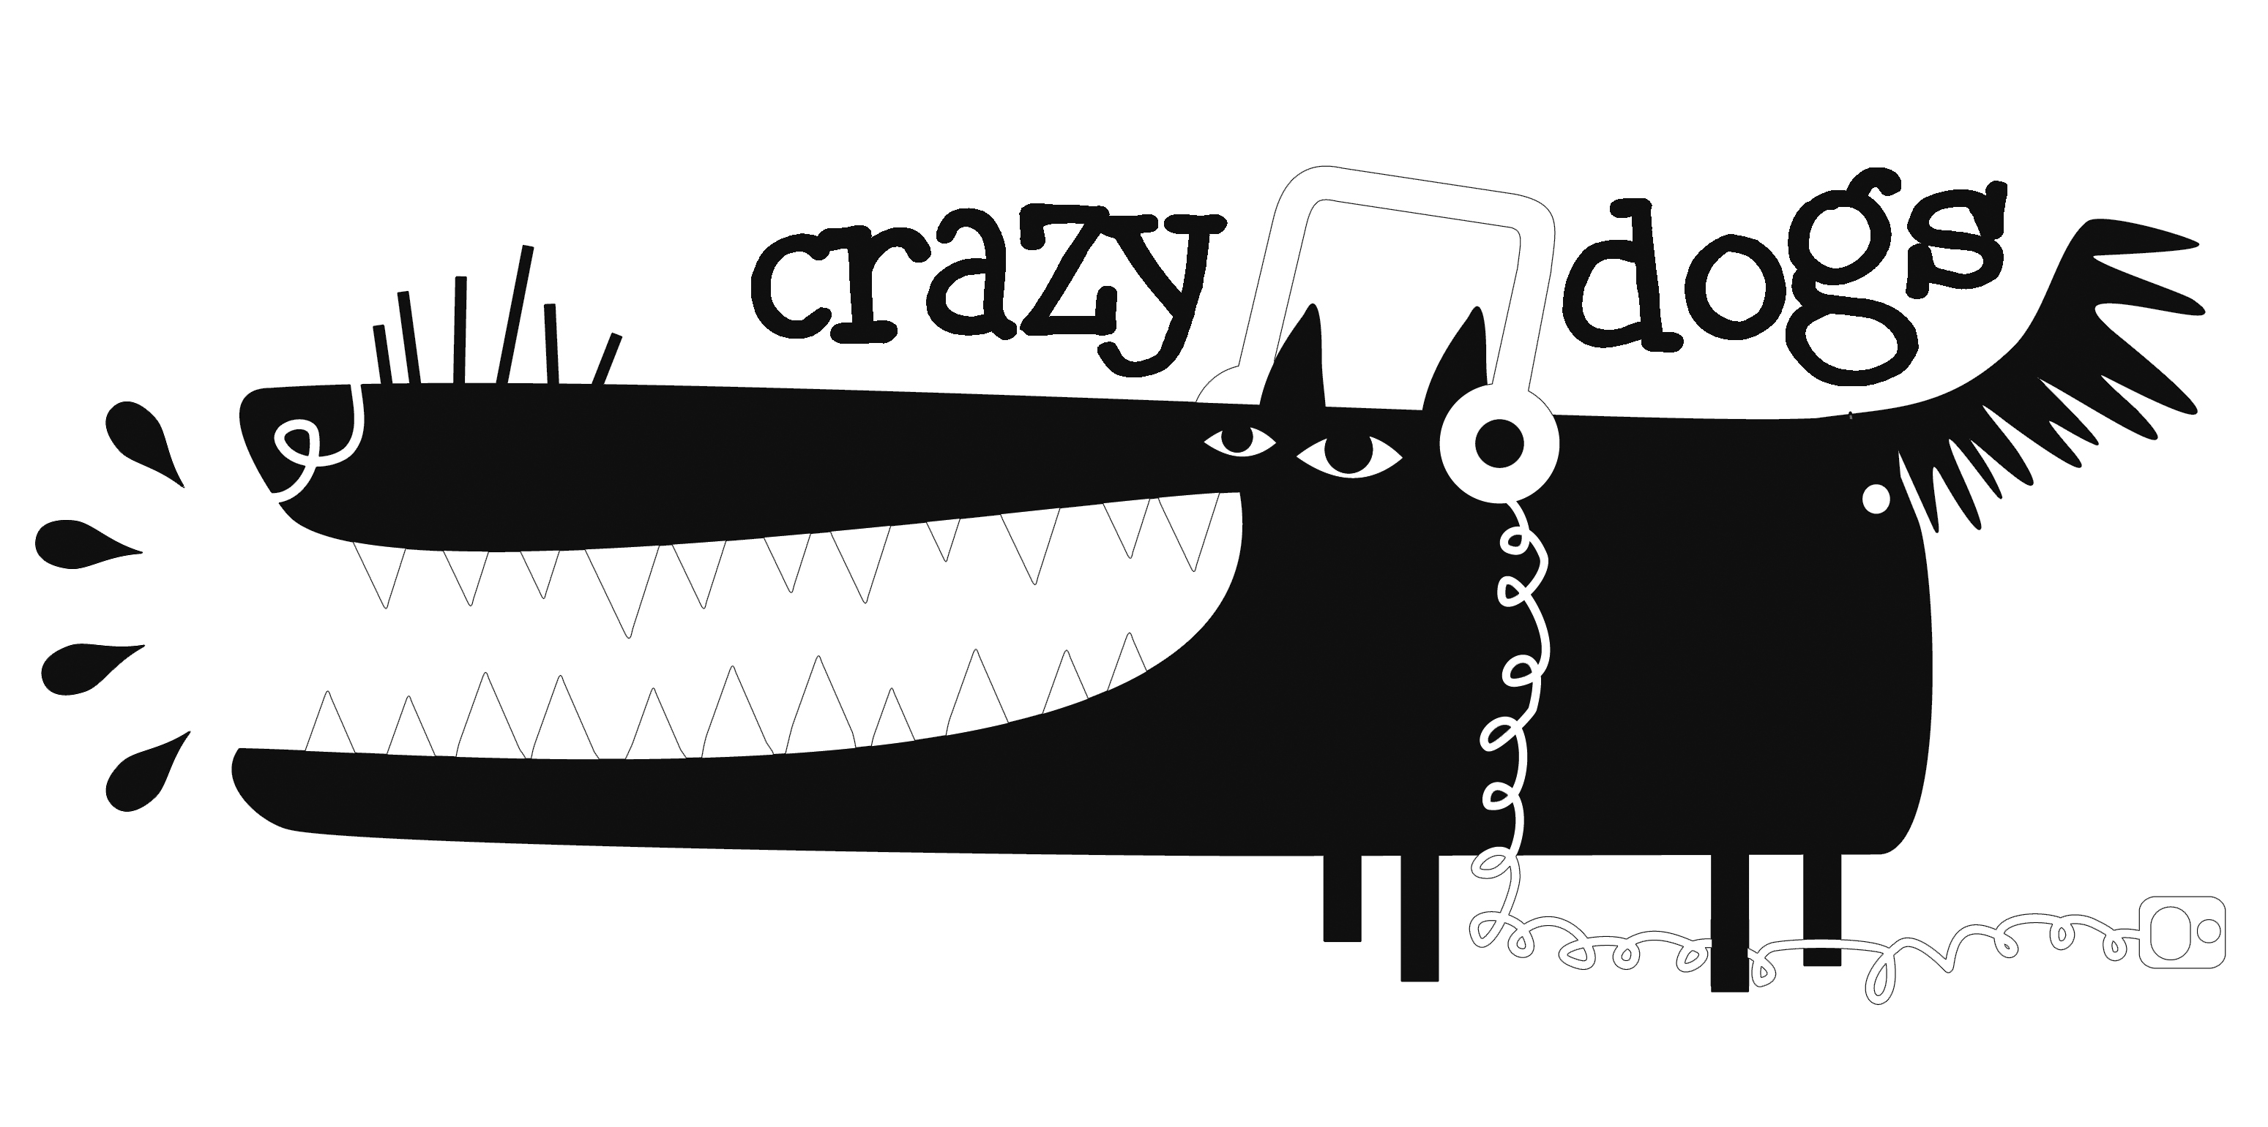
Crazy Dogs Playlist
Rock Around The Clock (Freedman and Myers)
See You Later Alligator (Robert Charles Guidry)
Sweet Nothin’s (Ronnie Self)
La Bamba (folk song)
The Twist (Hank Ballard)
Let's Twist Again (Kal Mann, Dave Appell)
Johnny B Goode (Chuck Berry)
Teddy Bear (Don Earl and Nick Nixon)
I Can’t Help Falling In Love With You (Hugo Peretti, Luigi Creatore and George David)
Raunchy (Bill Justis and Sid Manker)
Kansas City (Jerry Leiber and Mike Stoller)
Razzle Dazzle (Calhoun, Charles E.)
Don't Be Cruel (Otis Blackwell)
Hound Dog (Jerry Leiber and Mike Stoller)
Yakety Sax (Homer Louis "Boots" Randolph III)
Blue Suede Shoes (Carl Perkins)
Rebel Rouser (Duane Eddy)
Im So Lonesome I Could Cry (Hank Williams)
Lawdy Miss Clawdy (Lloyd Price)
Tutti Frutti (Richard Wayne Penniman and Dorothy LaBostrie)
Rip It Up (Robert Blackwell and John Marascalco)
Are You Lonesome Tonight (Lou Handman and Roy Turk)
Return to Sender (Winfield Scott and Otis Blackwell)
Slippin‘ and Slidin‘ (Maxwell Davis)
Misirlou (folk song)
You Never Can Tell (Chuck Berry)
Tequila (Daniel Flores)
Great Balls of Fire (Otis Blackwell and Jack Hammer)

